ICBM 2026 Paper Title Here

Completed Research Paper / Research-in-Progress

First Author
Institutional Affiliation and Address
e-mail

Second Author
Institutional Affiliation and Address
e-mail

Third Author
Institutional Affiliation and Address
e-mail

Fourth Author
Institutional Affiliation and Address
e-mail

Note
Authors’ details Should not be listed in the paper - they are supposed to be added during the submissions process in the Conference Management System (Microsoft CMT) and in the final Camera-Ready version.

Type of Submission
Please choose your relevant submission type above and keep it centered.

How to Use This Template
We suggest that the authors follow the formatting guidelines as mentioned in this template when making their submissions to ICBM 2026. The authors should format their papers exactly like this template or by using this template. The smartest way to use this template is to replace the relevant heading/text with your own text (preferably by using the merge formatting option while pasting the text) to help you reduce the work in formatting your papers.

Paper Title
You should use the style of paper title as above (which is configured as 16-point, Arial Black Font Style). Please ensure proper capitalization within your title (i.e. “Mohammad Ali Jinnah University” versus “mohammad ali jinnah university”.

Abstract
Abstract of the paper must not exceed 300 words.

Keywords
4-6 keywords should be mentioned separated by semicolons.

Page Size and Spacing
Please adhere to the Letter (8.5” x 11”) page size using the MS word. Authors of the accepted papers will be required to format their papers in this size. Please ensure your manuscript complies with the following instructions:
- Line spacing should be exactly 1.15.
- Margins should be 1 inch (2.54 cm).
- Do not use double spaces between the sentences.
- Please ensure all text should be justified.

Note: Non-compliance of these instructions may lead to desk rejection of your paper.

Length
The length for each submission type is specified in the ‘Submission Instruction’ heading available at the ICBM website. Any submission exceeding the page length limit will not be considered for review.

First Order Heading / Main Section
The heading of the main section should be kept as 14-point bold, left aligned, Century Gothic font style with initial letters capitalized. Sections should not be numbered.

Second Order Heading (Sub-sections)
The Second order heading should be kept as 12-point bold, left aligned, Century Gothic font style with initial letters capitalized. In any of the sub-sections and sub-subsections, please don’t capitalize the words like ‘of’, ‘the’, ‘an’, ‘a’ unless it is the first word of the heading.

Third Order Heading (Sub-subsections)
The Third Order heading should be kept as 11-point bold, Italic, left aligned, Century Gothic font style with initial letters capitalized.

Body Text
Please use the 10-point, justified “Century Gothic” style font for body text.

Figures, Tables & Captions
Pictures and Tables should be captioned using 10-point, bold, “Century Gothic” Style. They should be numbered as “Table 1: , Figure 2:”), centered and placed beneath the figure or table. Since all papers will be reviewed electronically, color figures are also encouraged.

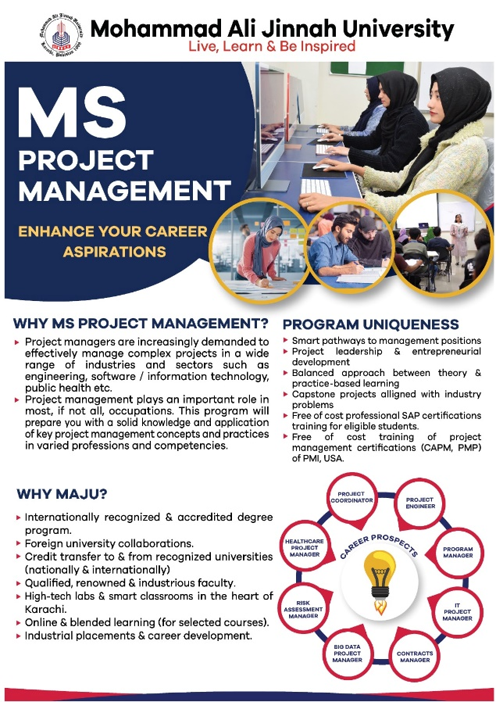
Figure 1: MAJU MS (Project Management) Program

R&D Performance Parameter | FoLS | FoBA | FoC | FSBS
Research Publications | 12 | 25 | 15 | 07
Research Grants | 07 | 12 | 25 | 15
Patents, Licences & Royalties | 12 | 07 | 15 | 25
R&D Consultancy Contracts | 07 | 12 | 25 | 15

Table 1: Sample Faculty Research Performance Output

Language, Style, and Content
With regard to punctuation and spelling, you are free to use any dialect of English (e.g., Canadian, US, British, Australian etc.) provided this is done consistently. In order to provide the best reading experience, please make sure take care of the following:
- Write in a clear and straightforward style.
- Try to avoid long or complex sentences.
- Briefly define all technical jargons or terms unfamiliar to the readers.
- Mention all the acronyms when they are used the first time – e.g., “Faculty of Business Administration (FoBA)”.

Conclusion
This template is intended to help you format your paper in a smooth and professional manner. By adhering to the above guidelines, you are helping the conference committee reduce unnecessary workload and ensure hassle free review process. The committee would like to thank you for your cooperation and look forward to receiving your paper that is formatted to high professional standards.

Acknowledgements (optional)
In order to keep the authors anonymous, acknowledgement should not be added to the first submission. Acknowledgement can be included once the paper is accepted.

References
References must be formatted using APA style. References must be complete, i.e., include, as appropriate, volume, number, publisher, last name & initials of all authors, page numbers, etc. If you use EndNote, be aware that different versions of the software change the styles, creating some inconsistencies. Your references should comprise only published materials accessible to the public. Proprietary information may not be cited. References should be ordered in alphabetic order. Please ensure that all references are present, complete, and accurate. Some sample reference entries are given below.

Fatima, H., Yasmin, B., & Almas, L.K. (2021). Technical efficiency and productivity analysis of bitter gourd-capsicum multiple cropping system under tunnels in Punjab, Pakistan. Sarhad Journal of Agriculture, 37(4), 1403-1417.
Qureshi, M.A., Waseem, N., Qureshi, J.A., & Afshan, S. (2018). Impact of Organizational Commitment on Readiness for Change: A Case of Higher Learning Institutions of Karachi. JISR management and social sciences & economics,16(1), 1-14.
Rehman, J., Sohaib, O., Asif, M., & Pradhan, B. (2019). Applying systems thinking to flood disaster management for a sustainable development. International Journal of Disaster Risk Reduction, 36. https://doi.org/10.1016/j.ijdrr.2019.101101.
Muhammad, G., & Naz. F. (2022). HR audit is a tool for employee retention and organisational citizenship behaviour: a mediating role of effective HR strategies in services sector of emerging economies. Middle East Journal of Management, 10(1), 98-112. https://doi.org/10.1504/MEJM.2023.127761.
Abbas, Q., Khan, M.A., & Hussain, J. (2017). Relationship between types of rewards and job satisfaction of employees: evidence from Khyber Pakhtunkhwah. Pakistan Business Review, 18(4), 829-847.

